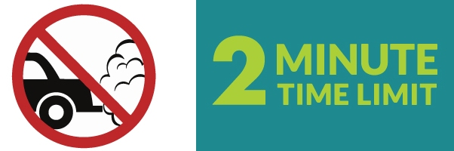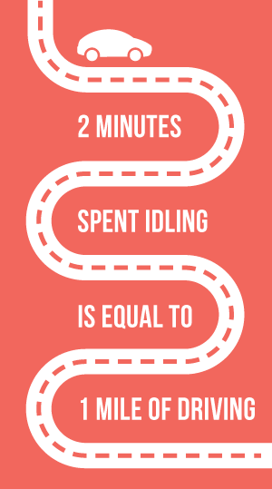



**Take the Idle Free Pledge**

As you may be aware, SLC Ordinance 12.58.030 prohibits idling longer than two minutes. Be a part of supporting clean air by helping this student **have idle free conversations with drivers in your community**; being idle free is about the health of young scholars, and it’s the law. The pledge is due back to class on ____________. Thank you for making this easy change to clear the air!

**Take the Idle Free Pledge**

As you may be aware, SLC Ordinance 12.58.030 prohibits idling longer than two minutes. Be a part of supporting clean air by helping this student **have idle free conversations with drivers in your community**; being idle free is about the health of young scholars, and it’s the law. The pledge is due back to class on ____________. Thank you for making this easy change to clear the air!

**Take the Idle Free Pledge**

As you may be aware, SLC Ordinance 12.58.030 prohibits idling longer than two minutes. Be a part of supporting clean air by helping this student **have idle free conversations with drivers in your community**; being idle free is about the health of young scholars, and it’s the law. The pledge is due back to class on ____________. Thank you for making this easy change to clear the air!

**Take the Idle Free Pledge**

As you may be aware, SLC Ordinance 12.58.030 prohibits idling longer than two minutes. Be a part of supporting clean air by helping this student **have idle free conversations with drivers in your community**; being idle free is about the health of young scholars, and it’s the law. The pledge is due back to class on ____________. Thank you for making this easy change to clear the air!